**Lymphedema**

Lymphedema is swelling that happens when something affects your lymphatic system. Lymphedema often affects your arms and legs, but may also affect other areas of your body. Healthcare providers can’t cure lymphedema, but they can ease its symptoms.

**Overview**

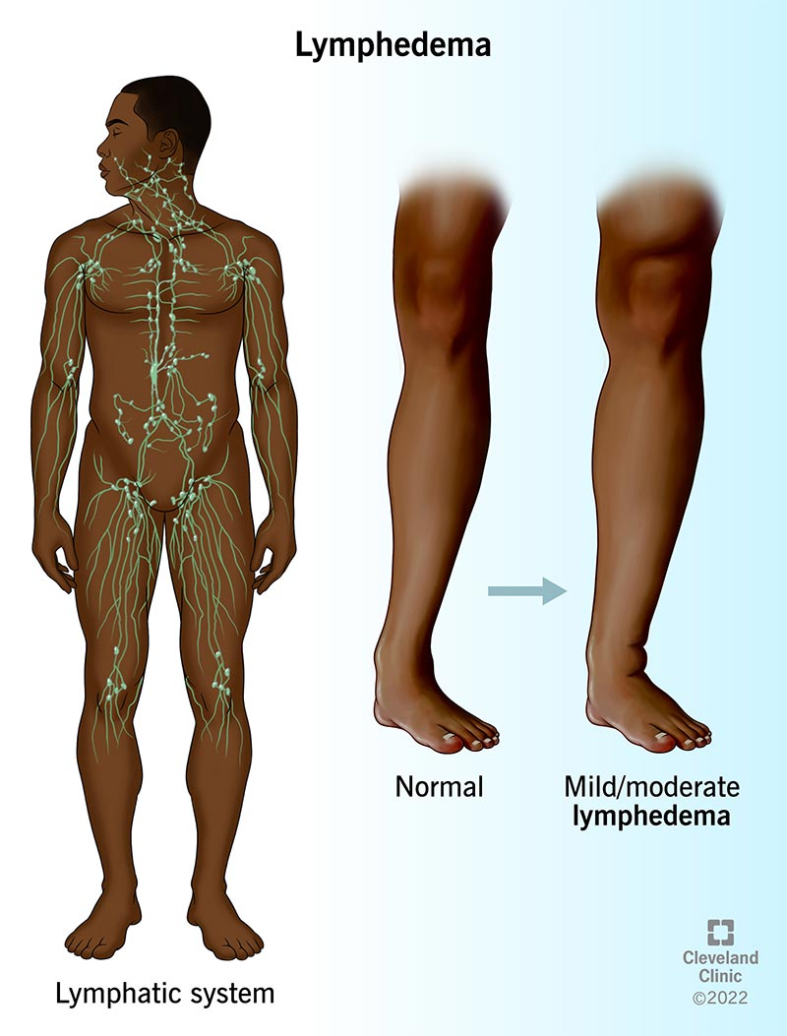Lymphedema is swelling that happens when something affects your lymphatic system (center). Lower leg without lymphedema (right). Lower leg with mild/moderate lymphedema (left).

**What is lymphedema?**

Lymphedema is swelling in various areas of your body that happens when something affects your [lymphatic system](https://my.clevelandclinic.org/health/articles/21199-lymphatic-system). Your lymphatic system collects excess fluid, proteins and toxins from your cells and tissues and returns them to your bloodstream.

When your lymphatic system doesn’t work well, your body accumulates fluid and may begin to swell. The swelling typically affects your arms and legs, but it can affect other areas of your body, too. Lymphedema also increases your risk of developing an infection where you have the condition.

This can happen after certain surgeries or because you have certain medical conditions or genetic conditions. You may develop lymphedema spontaneously, meaning it happens for no known reason.

Lymphedema symptoms may be mild, causing minor swelling and discomfort. Sometimes, however, lymphedema may cause significant swelling that can be painful and cause skin issues such as infections and wounds. Healthcare providers can’t [cure](https://my.clevelandclinic.org/health/articles/24434-cure) lymphedema, but they do have treatments to reduce swelling and discomfort. There are also many things you can do to limit the impact lymphedema may have on your quality of life.

**How does lymphedema affect my body?**

If you have lymphedema, your arms, legs, feet and other areas of your body may look and feel swollen. Lymphedema can be painful and may affect your ability to manage daily activities. Many people with lymphedema feel self-conscious about the ways it changes their appearance.

**Is lymphedema a serious medical condition?**

It can be. If you have lymphedema, you may be at risk of developing infections that start in your skin. These infections may be life-threatening. Rarely, lymphedema may also lead to lymphangiosarcoma, a very rare skin cancer.

**Are there different types of lymphedema?**

Yes, there are two types of lymphedema — primary and secondary.

**What is primary lymphedema?**

Primary lymphedema comes from rare, inherited conditions that affect how your lymphatic system develops. Primary lymphedema affects about 1 in 100,000 people in the U.S. Lymphedema from these conditions can appear at these ages:

* **Infancy**: Infants may be born with [Milroy’s disease](https://my.clevelandclinic.org/health/diseases/milroys-disease), an inherited form of lymphedema.
* **Puberty, during pregnancy or up until age 35**: [Meige disease](https://my.clevelandclinic.org/health/diseases/meige-disease" \t "_blank) (lymphedema praecox) may affect people going through puberty or pregnancy and up until age 35.
* **After age 35**: A rare, late-onset lymphedema (lymphedema tarda) can cause lymphedema, with swelling limited to your legs.

**What is secondary lymphedema?**

Secondary lymphedema may happen if your lymphatic system is damaged from surgery, trauma or radiation therapy. It is most common in people who’ve had breast cancer treatment. That said, not everyone who has breast cancer treatment develops lymphedema.

**Is lymphedema a form of cancer?**

No, it’s not a form of [cancer](https://my.clevelandclinic.org/health/diseases/12194-cancer).

**Symptoms and Causes**

**What are lymphedema symptoms?**

The most common symptom is swelling. Swelling may develop slowly. You may not notice unusual swelling in lymphedema’s early stages. Swelling from lymphedema may also come on suddenly. Other lymphedema symptoms you may notice include:

* You can’t see or feel the [veins](https://my.clevelandclinic.org/health/body/23360-veins) or [tendons](https://my.clevelandclinic.org/health/body/21738-tendon) in your hands and feet.
* Your arms or legs appear to be slightly different sizes.
* It feels as if your [joints](https://my.clevelandclinic.org/health/body/25137-joints) are unusually tight or inflexible.
* [Your skin seems puffy or red](https://my.clevelandclinic.org/health/diseases/24388-venous-stasis-dermatitis).
* Swelling in your arms or legs or other areas of your body.
* Your arms, legs or other parts of your body feel uncomfortably heavy or full.
* Your clothes or jewelry fit more tightly than usual.
* You have a feeling of burning or itching.
* Your [skin](https://my.clevelandclinic.org/health/body/10978-skin) becomes noticeably thicker.

**What causes lymphedema?**

Several things may cause lymphedema, including:

* [**Breast cancer surgery**](https://my.clevelandclinic.org/health/treatments/8338-breast-cancer-surgery): Sometimes, breast cancer surgery includes removing lymph nodes under your arms and possibly damaging nearby lymph vessels.
* [**Pelvic surgery**](https://my.clevelandclinic.org/health/diseases/8634-prostate-cancer): Surgery to remove pelvic lymph nodes may cause lymphedema.
* [**Radiation therapy**](https://my.clevelandclinic.org/health/treatments/17637-radiation-therapy): Radiation therapy may cause scarring and damage to your lymphatic system, inflaming your skin and placing pressure on your lymphatic circulation system.
* **Trauma**: Your lymphatic system is a rich network of vessels that are directly under your skin, as well as deep. Sometimes, trauma to an area of your body may damage lymphatic vessels under your skin, causing lymphedema.
* **Infection**: An infection may increase lymphatic system damage.
* **Having**[**obesity**](https://my.clevelandclinic.org/health/diseases/11209-weight-control-and-obesity): People who have obesity may have excess fat (adipose tissue) that puts pressure on lymph nodes and vessels. That extra pressure may affect lymphatic drainage.
* **Lack of activity**: Your leg muscles pump up lymphatic circulation. If you’re not active, you may have swelling in your legs.
* **Tumors**: [Tumors](https://my.clevelandclinic.org/health/diseases/21881-tumor) may block lymphatic drainage.
* **Heart conditions**: People who have heart issues, particularly [congestive heart failure](https://my.clevelandclinic.org/health/diseases/17069-heart-failure-understanding-heart-failure), may develop lymphedema. Your lymphatic ducts empty [lymph](https://my.clevelandclinic.org/health/body/25209-lymph) back into your heart. If your heart isn’t working as well as it should, you may notice you’re gaining weight or your legs are swollen.
* **Blood vessel issues**: Your [blood vessels](https://my.clevelandclinic.org/health/body/21640-blood-vessels) carry between 80% and 90% of fluid throughout your body. When something affects your blood vessels (vascular system), you may develop chronic blood vessel issues. Chronic blood vessel issues may cause lymphedema.
* [**Kidney disease**](https://my.clevelandclinic.org/health/diseases/15096-chronic-kidney-disease): Your kidneys work to remove extra fluid and waste products from your body. If your kidneys don’t function as they should, your body may have trouble removing fluid. Excess fluid may cause swelling that leads to lymphedema.

**Diagnosis and Tests**

**How do healthcare providers diagnose lymphedema?**

If you have swelling that may be due to lymphedema, your healthcare provider may do several tests to determine if lymphedema is causing the swelling. Those tests may include:

* [**Doppler ultrasound**](https://my.clevelandclinic.org/health/diagnostics/22715-doppler-ultrasound): This test looks at blood flow by bouncing high-frequency sound waves (ultrasound) off red blood cells. It can help find obstructions and rule out other possible causes of swelling, like blood clots.
* [**Magnetic resonance imaging (MRI)**](https://my.clevelandclinic.org/health/diagnostics/4876-magnetic-resonance-imaging-mri): This test uses a magnet, radio waves and a computer to make a series of detailed 3D (three-dimensional) pictures inside of your body. Healthcare providers may use this test to see if something, such as a tumor, is putting pressure on your lymphatic system.
* [**Computed tomography (CT) scan**](https://my.clevelandclinic.org/health/diagnostics/4808-ct-computed-tomography-scan):This test uses X-rays to show detailed, cross-sectional images of your body’s structures. Like an MRI, healthcare providers may use this test to check for signs something is putting pressure on your lymphatic system.

**Are there stages of lymphedema?**

Yes, healthcare providers use the following staging system:

* **Stage 0**:The affected area may feel swollen, tight and heavy but without outside signs of swelling.
* **Stage I**: There may be occasional swelling that goes away when you elevate the affected area.
* **Stage II**: The affected area is almost always swollen and your skin in the area may feel firmer than the surrounding area.
* **Stage III**: The affected area has significant swelling with changes in your skin such as changes in its color and texture.

**Management and Treatment**

**How do you get rid of lymphedema?**

There’s no cure for lymphedema, which means you can’t get rid of it. There are many different ways to treat lymphedema so it doesn’t affect your quality of life.

**What are lymphedema treatments?**

Lymphedema treatments vary depending on your condition’s cause and stage. Treatments may include physical therapy or other treatment to keep lymphatic fluid moving and reduce swelling and pain. Your healthcare provider may also prescribe antibiotics for infections or pain medication.

**What are physical treatments for lymphedema?**

Lymphedema treatment typically includes a combination of physical therapy and garments or bandaging that moves fluid from areas affected by lymphedema. If you have physical therapy for lymphedema, it’s very important to use garments or bandaging after therapy to maintain the treatment’s effect. Physical treatments for lymphedema may include:

* [**Compression garments**](https://my.clevelandclinic.org/health/treatments/23449-compression-therapy): Compression garments may be socks, sleeves or wraps that have pressure to move fluid from your tissues into circulation. This reduces swelling and your risk of lymphedema complications.
* [**Physical therapy**](https://my.clevelandclinic.org/health/treatments/physical-therapy): Physical therapists who specialize in lymphedema do a gentle form of massage to stimulate circulation. This is [manual lymphatic drainage](https://my.clevelandclinic.org/health/treatments/21768-lymphatic-drainage-massage) (MLD). The therapists may teach you how to perform this massage on your own.
* **Multilayer compression bandaging**: After manual lymphatic drainage treatment, your physical therapist may place multilayer compression bandages on the swollen areas of your body. (If you’ve ever sprained an ankle, you may have put a short stretch bandage on your ankle to keep it from swelling. Multilayer compression bandaging acts the same way on your lymphedema.) Physical therapists layer bandages to put different levels of pressure on the swollen areas of your body. The bandages put pressure on your tissues, moving fluid back into circulation.
* **Compression devices**: These pneumatic compression pumps provide on-and-off pressure to keep fluid moving through your lymph vessels and veins so it doesn’t build up in your arms, legs and other parts of your body. The devices work by connecting the pump to a sleeve that wraps around your affected areas. The pump drives a regular cycle of pressure that inflates and deflates the sleeve. Compression pumps may also reduce complications of lymphedema.
* **Elevation**: Gravity plays a role in lymphedema symptoms. You should try to keep the affected area of your body elevated as much as possible.
* **Exercise**: Physical exercise is important to stimulate lymphatic drainage.

**Are there surgical treatments for lymphedema?**

Healthcare providers may recommend surgery if nonsurgical treatments haven’t helped your symptoms. It’s done at centers that specialize in this treatment. Lymphedema surgery is usually only done if your lymphedema is severe. It isn’t a complete cure either. Not everyone can have surgery. If you have lymphedema, ask your healthcare provider if surgery makes sense for you. Surgical treatments may include:

* **Lymphatic bypass procedure**: This surgery involves connecting and rerouting lymphatic vessels and veins so they avoid obstructions and let lymph drain into your body’s venous system.
* **Lymph node transfer**: Surgeons replace damaged [lymph nodes](https://my.clevelandclinic.org/health/body/23131-lymph-nodes) with healthy lymph nodes taken from other areas in your body, essentially creating a new lymphatic system for the area of your body affected by lymphedema.
* **Debulking**: This surgery treats very severe forms of lymphedema. It involves surgically removing all skin, fat and tissue in the affected area of your body and then placing a skin graft over this area.

**Prevention**

**How can I reduce my risk of developing lymphedema?**

You can’t reduce all lymphedema risks, but there are things you can do to reduce and possibly prevent swelling. If you’re having breast cancer surgery or other treatment, ask your surgeon and other healthcare providers about exercises that may reduce swelling. Other steps include:

* **Monitoring your body**: Ask your healthcare provider about measuring the affected area of your body to keep track of minor changes that may be signs of lymphedema that happen before you notice any swelling. Spotting changes early can help you get started on treatment right away.
* **Elevating affected areas**: Whenever you can, keep your affected arm or leg lifted above your heart.
* **Keep moving**: While you’re recovering, find ways to move around slowly so you keep fluids moving.
* **Avoiding extreme temperatures**: Extreme heat may increase your risk of lymphedema.

**Additional recommendations**

It can be hard to get comfortable when your arm or leg is swollen. These suggestions may be helpful:

* **Stay loose**: Wear loose-fitting clothes that won’t feel tight on your legs and arms. Avoid tight-fitting socks, tights and hosiery and wear comfortable, closed-toe shoes. You may not be able to wear jewelry or watches on your affected arm, but if you can, make sure your watch or jewelry isn’t squeezing your arm.
* **Sit properly**: When you’re sitting, keep your feet flat on the floor and avoid crossing your legs so fluid in your legs can keep moving. Try to take breaks every 30 minutes to get up and move around.
* **Travel safe**: If you have a flight in the near future, ask your healthcare provider if you should wear compression garments on your affected arm or leg.

**When should I see my healthcare provider?**

Contact your healthcare provider if you notice your affected arm or leg is more swollen or if you think you have an infection.

**Outlook / Prognosis**

**What can I expect if I have lymphedema?**

Lymphedema is a chronic condition. Treatment and lifestyle changes don’t cure lymphedema but they’re effective ways to manage lymphedema symptoms.

**Living With**

**How do I manage lymphedema?**

While there’s no cure for lymphedema, making small changes in how you go about your day may help reduce swelling and other symptoms. Small changes to consider include protecting against infection, getting exercise and making small changes in your diet.

**How do I protect myself from infections?**

Lymphedema puts stress on your skin, making it more vulnerable to infection from injuries like cuts, scrapes and scratches. Infections may create serious medical issues for people with lymphedema. You can help protect yourself by practicing good hygiene and protecting your skin. Suggestions include:

* **Wash your hands**: Use soap and warm water to wash your hands throughout the day and before preparing food and after going to the bathroom or touching dirty clothes or linens.
* **Protect your skin**: Wear gloves to avoid scratches. Use an electric razor when you shave. Wear insect repellent to avoid bug bites that could make you want to scratch. Wear sun protection (SPF 30 or higher) when you go outside.
* **Treat any injuries right away**: Even minor injuries can lead to infections. If you have cuts or scratches, wash the injury with soap and water, apply antibiotic ointment and put a bandage on your injury. Call your healthcare provider if you see any signs of infection, including redness, pain, increased swelling or fever.

**How does exercise help with lymphedema?**

Lymphedema happens when fluid gathers in one spot in your body. Exercise is one of the best ways to keep fluid moving. Talk to your healthcare provider before starting an exercise routine. They’ll have suggestions and may recommend special exercises you can do. Other suggestions are:

* **Warm-up and cool down**: No matter your routine, start with a five-minute warm-up of stretches and end with a five- to 10-minute cool down.
* **Take it slow**: Give your body time to adjust to your exercise routine. Start with 10 minutes of exercise, with a goal of doing 20 to 30 minutes of exercise each day.
* **Take it easy**: Avoid strenuous exercise that puts pressure on your affected arm or leg.
* **Wait on weights**: If you normally lift weights or do strength training, ask your healthcare provider when you can resume training. They may have suggestions on exercises you should avoid or limits on the amount of weight you should lift.
* **Don’t push yourself**: Pay attention to your affected arm or leg and take a break if you notice your arm or leg begins to weaken. Do your cool-down routine and then rest your arm or leg, elevating it above your heart.
* **Don’t** **push through pain**: Stop any exercise that hurts and contact your provider. They may want to check your affected arm or leg.

**How does changing my diet help?**

Healthy eating habits may help you control swelling. Your lymphatic system is more effective when it’s powered by nutrients from fruits, vegetables, whole grains and lean protein. Healthy eating also helps you maintain a weight that’s right for you. Some suggestions include:

* **Pass (on) the salt**: Salt can make you retain fluids. Try fresh herbs and other seasonings to spice up your food.
* **Drink your water**: Drinking eight 8-ounce glasses of water every day helps flush out fluids.

**A note from Cleveland Clinic**

Lymphedema is swelling in various areas of your body that happens when something affects your lymphatic system. It’s a chronic condition that may take a toll on your health, your spirits and your self-esteem. Lymphedema is a tough condition. But you can take steps to control your symptoms and make it easier to live with lymphedema. Small changes such as eating a healthy diet and adding exercise can make a big difference. Your healthcare provider can also recommend treatments to ease lymphedema symptoms. Let them know if you’re having trouble living with lymphedema. They’ll give you the help you need or point you in the right direction to find that help.